<https://www.atlassian.com/git/tutorials/what-is-version-control>

<https://www.javatpoint.com/git-rebase>

20. Merge a Branch to Master & identifying difference **-- >** **Stash important concept**

git — Rebase vs Merge

<https://medium.com/datadriveninvestor/git-rebase-vs-merge-cc5199edd77c>

|  |  |
| --- | --- |
| Image for post  **When to rebase? When to Merge?**  If the **feature branch you are getting changes from is shared with other developers,** **rebasing is not recommended**, because the **rebasing process will create inconsistent repositories.** For individuals, rebasing makes a lot of sense.  If you want to see the history completely same as it happened, you should use merge. **Merge preserves history whereas rebase rewrites it.** | When you do **rebase a feature branch onto master, you move the base of the feature branch to master branch’s ending point.**  **Merging takes the contents of the feature branch and integrates it with the master branch.** As a result, only the master branch is changed. The feature branch history remains same.  Merging adds a new commit to your history. |

[Git: Become an Expert in Git & GitHub in 4 Hours](https://www.udemy.com/course/git-expert-4-hours/)

Your progress

Share

## Section 3: Git Basics

**** very important –

<https://github.com/joshnh/Git-Commands>

[Git and GitHub - Step by Step for Beginners](https://www.udemy.com/course/draft/1646770/)

Your progress

Share

## Section 2: Basics of BRANCHING

6. Branching and Merging

7. How to send email from GitHub

Watch Video…

How to trigger notification email from github whenever there is any change/commit in the project _________________________________________ Step 1 : Github - Repository - Settings - integration & services - add email Step 2 : Test and validate by making some change in the project

8. Git Tags - what, why, when and how

Today We will learn:

1. What are tags / releases

2. Why should i create TAGs

3. When to create TAGs

4. How to create TAGs in git

create | show | publish | delete

Step 1:

Checkout the branch where you want to create the tag

git checkout "branch name"

example : git checkout master

________________________________________________________

Step 2:

Create tag with some name

git tag "tag name"

example : git tag v1.0

git tag -a v1.0 -m "ver 1 of .." (to create annotated tags)

________________________________________________________

Step 3:

Display or Show tags

git tag

git show v1.0

git tag -l “v1.*”

________________________________________________________

Step 4:

Push tags to remote

git push origin v1.0

git push origin --tags

git push --tags

(to push all tags at once)

________________________________________________________

Step 5:

Delete tags (if required only)

to delete tags from local :

git tag -d v1.0

git tag --delete v1.0

to delete tags from remote :

git push origin -d v1.0

git push origin --delete v1.0

git push origin :v1.0

to delete multiple tags at once:

git tag -d v1.0 v1.1 (local)

git push origin -d v1.0 v1.1 (remote)

________________________________________________________

Checking out TAGS

**We cannot checkout tags in git**

We can create a branch from a tag and checkout the branch

git checkout -b "branch name" "tag name"

example : git checkout -b ReleaseVer1 v1.0

________________________________________________________

Creating TAGS from past commits

git tag "tag name" "reference of commit"

example : git tag v1.2 5fcdb03

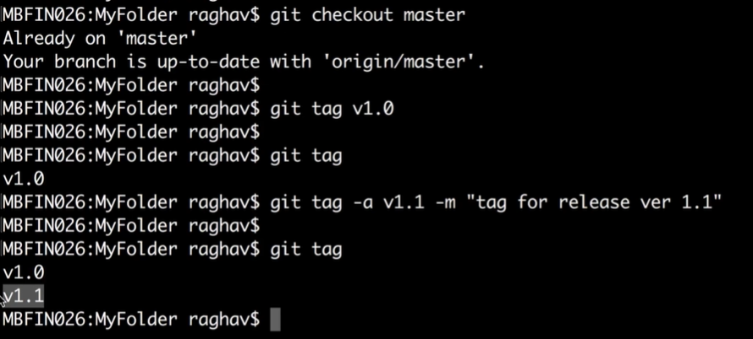

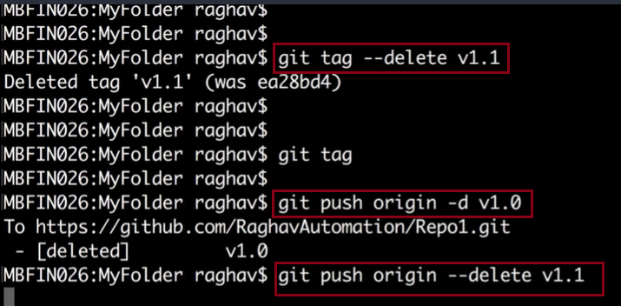

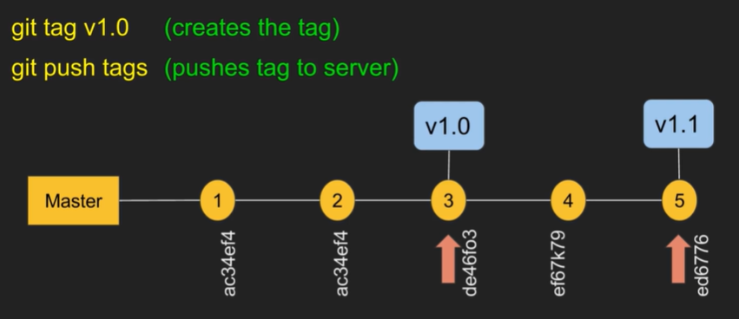

### git log

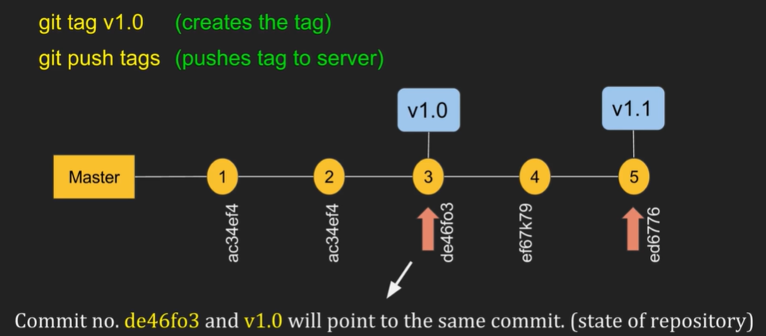

Checking out TAGS

**We cannot checkout tags in git**

We can create a branch from a tag and checkout the branch

git checkout -b "branch name" "tag name"

example : git checkout -b ReleaseVer1 v1.0

Creating TAGS from past commits

git tag "tag name" "reference of commit"

example : git tag v1.2 5fcdb03

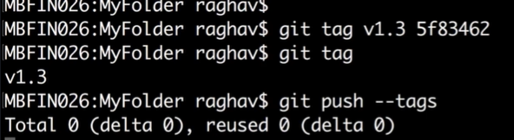

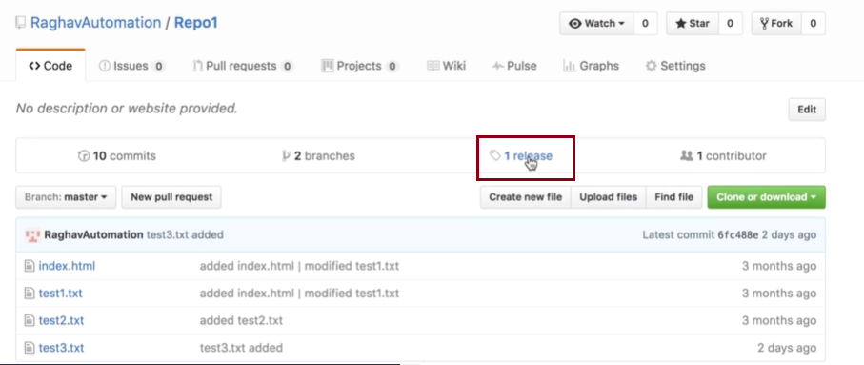

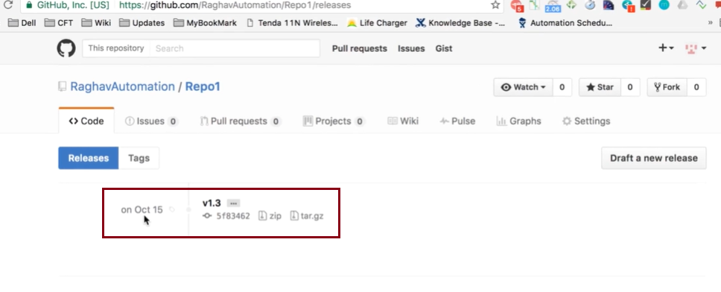

**Learn Git**

Learn Git with Bitbucket Cloud

Create a Git repository

Copy your Git repository and add files

Pull changes from your Git repository on Bitbucket Cloud

Use a Git branch to merge a file

Learn about code review in Bitbucket Cloud

Learn branching in Bitbucket Cloud

Learn undoing changes with Bitbucket Cloud

---------------------------------------------

[Get the GIT : Learn GIT with Bitbucket](https://www.udemy.com/course/get-the-git-learn-git-with-bitbucket/)

## Section 5: Branching & Merging with GIT

### 18. Create and Change Branch

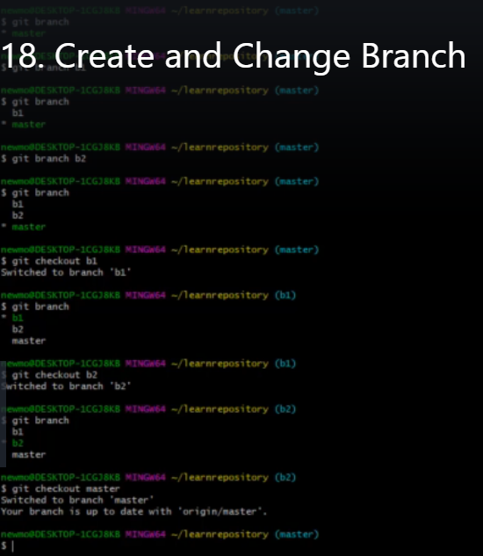

C:\Users\kumar>cd C:\Users\kumar\Documents\changetomorrow\Backend

C:\Users\kumar\Documents\changetomorrow\Backend>git branch

* changetomorrow

C:\Users\kumar\Documents\changetomorrow\Backend>git branch feature_enroll_types

C:\Users\kumar\Documents\changetomorrow\Backend>git branch

* changetomorrow

feature_enroll_types

C:\Users\kumar\Documents\changetomorrow\Backend>git checkout feature_enroll_types

Switched to branch 'feature_enroll_types'

M Backend/pom.xml

M Backend/src/main/java/com/changetomorrow/exception/EntityNotFoundException.java

M Backend/src/main/java/com/changetomorrow/exception/UserExceptionHandler.java

C:\Users\kumar\Documents\changetomorrow\Backend>git branch

changetomorrow

* feature_enroll_types

C:\Users\kumar\Documents\changetomorrow\Backend>git checkout changetomorrow

Switched to branch 'changetomorrow'

M Backend/pom.xml

M Backend/src/main/java/com/changetomorrow/exception/EntityNotFoundException.java

M Backend/src/main/java/com/changetomorrow/exception/UserExceptionHandler.java

Your branch is up to date with 'origin/changetomorrow'.

C:\Users\kumar\Documents\changetomorrow\Backend>

### 19. Merge Master to a Branch

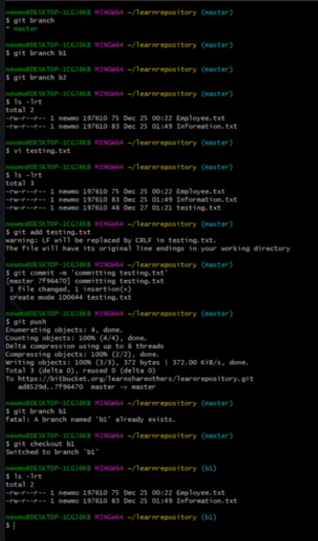

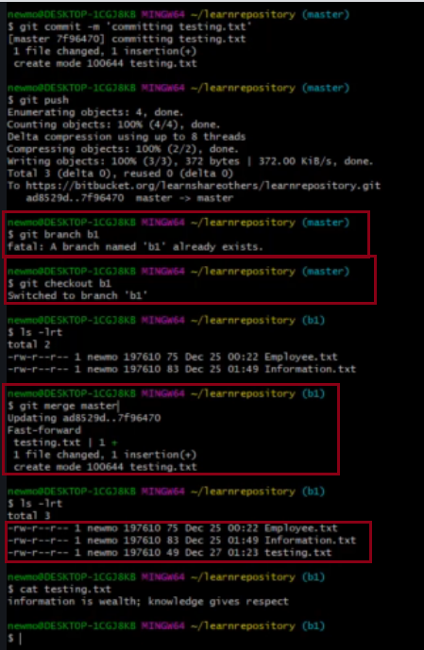

### 20. Merge a Branch to Master & identifying difference

### Stash important concept

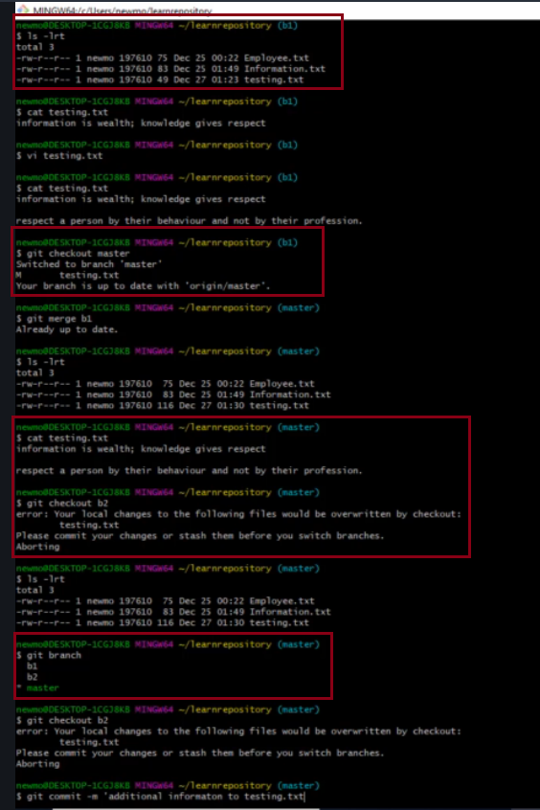

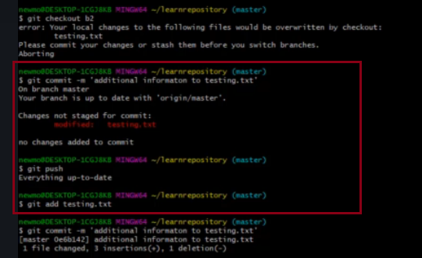

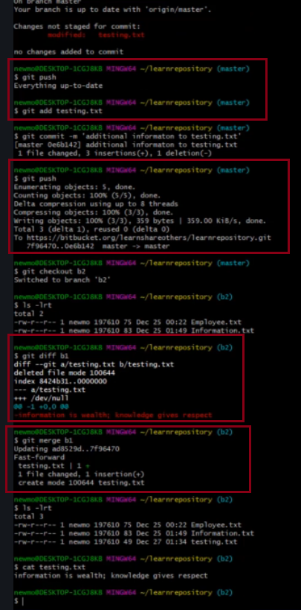

----------------------------------------------------------------------------------------------------------------------------------------------------------

Udemy : Clary

Git & GitHub Crash Course: Create a Repository From Scratch!

6. Adding Files and Staging Them

[GIT Crash Course](https://www.udemy.com/course/gitbyavinash/)

## 13. Branching

**Need to watch video… for more clarity**

**clone == copying**

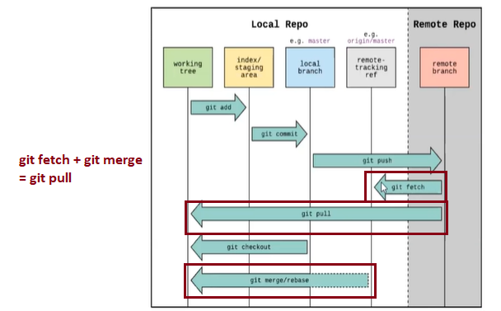

## 12. Pull Requests

### 5. Understanding GIT Terminology

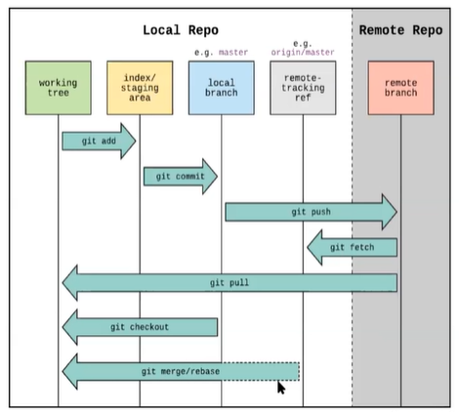

### 6. Add, Commit and Status Commands

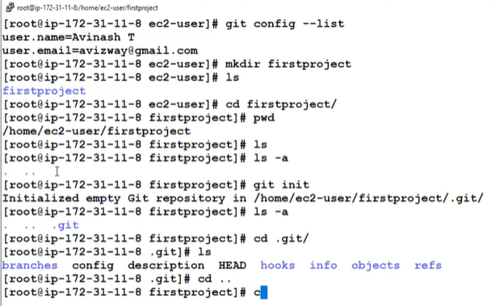

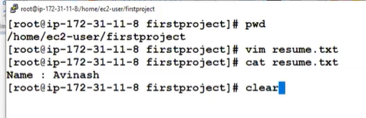

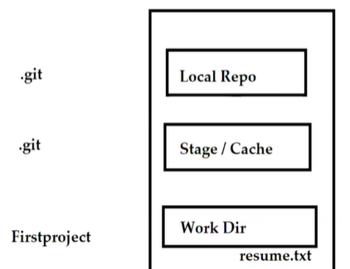

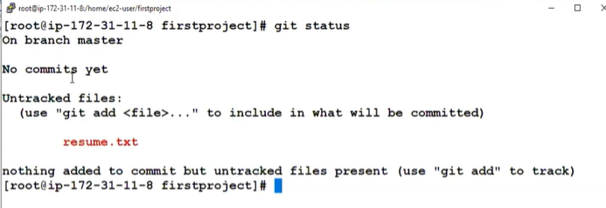

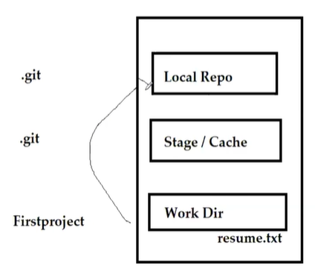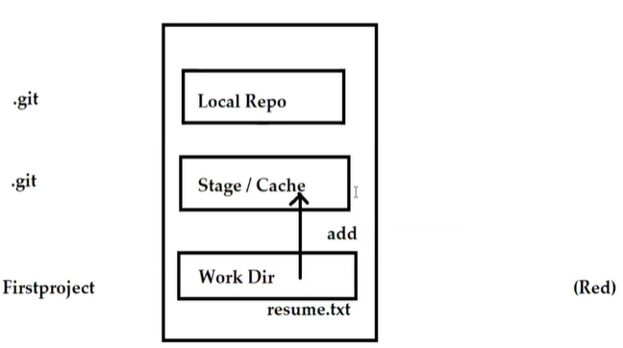

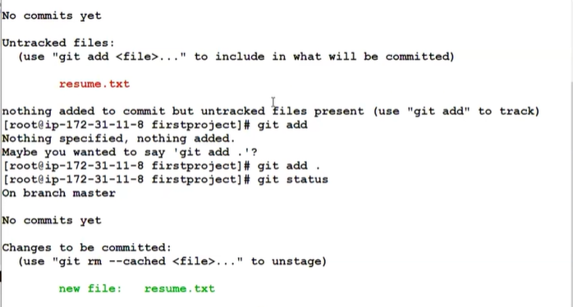

#### git add one file

#### git add . all file

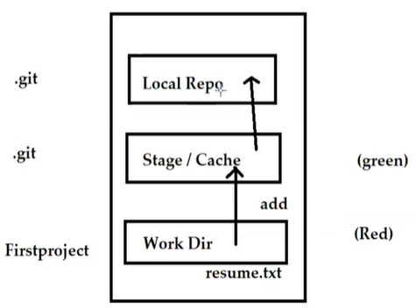

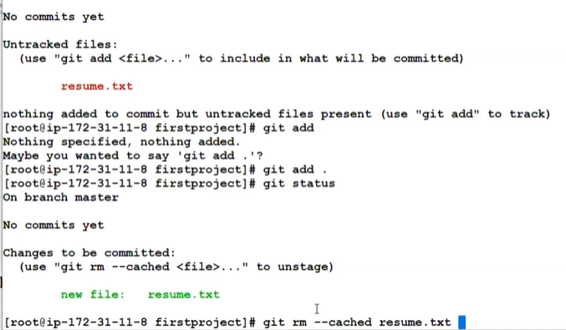

git rm –cached resume.txt

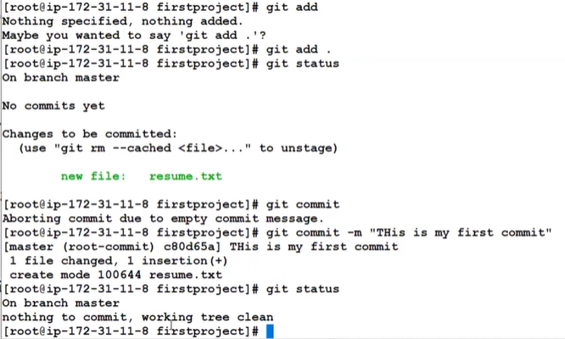

git commit

git commit -m “This is my first Message”

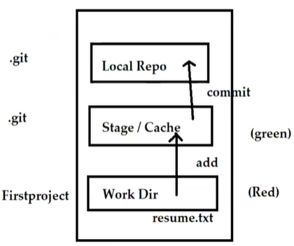

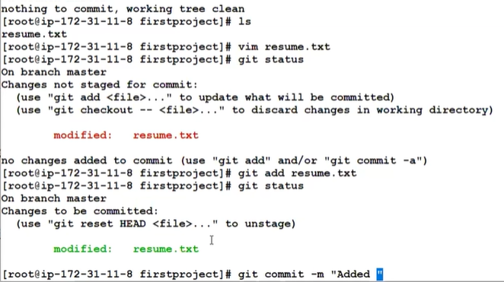

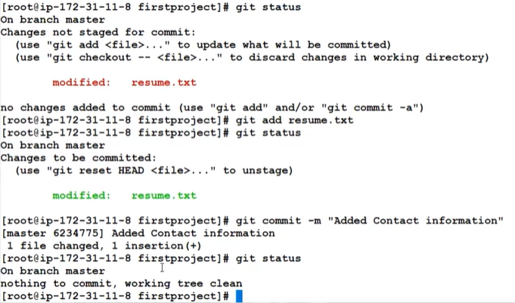

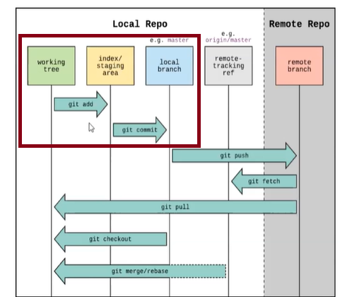

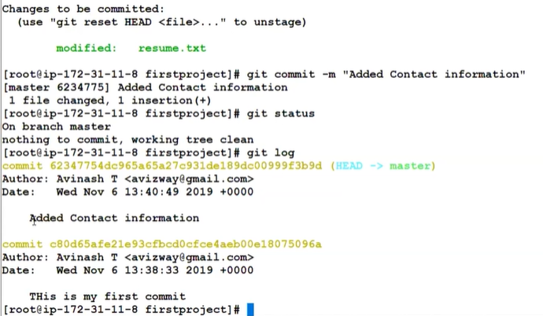

git log

## 7. Understanding GIT Logs

### git log

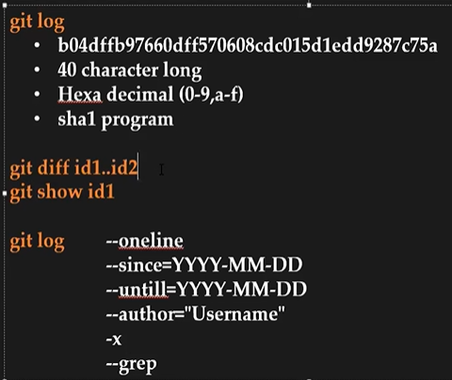

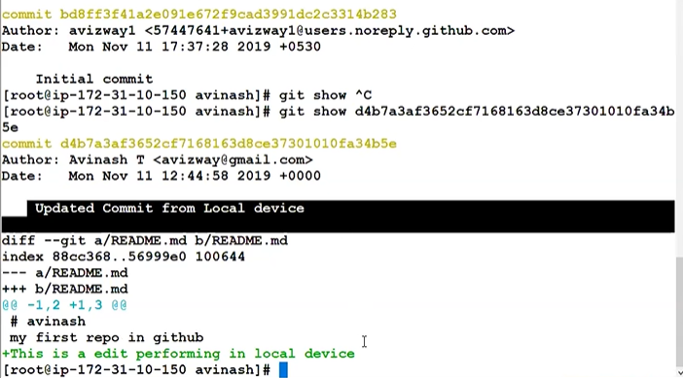

### git log --oneline

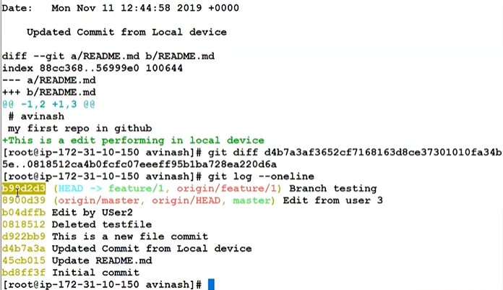

git diff bd8ff3f..d4b7a3a

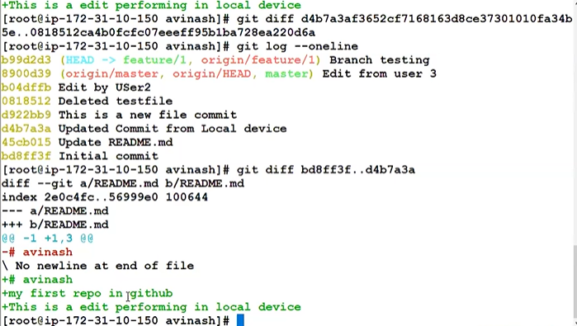

### git log –oneline --author=avizway1

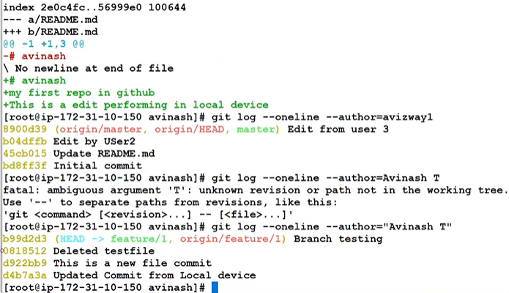

Last 2 comments **-2**

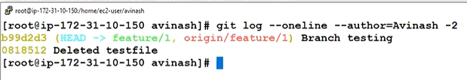

## 8. GIT Ignore

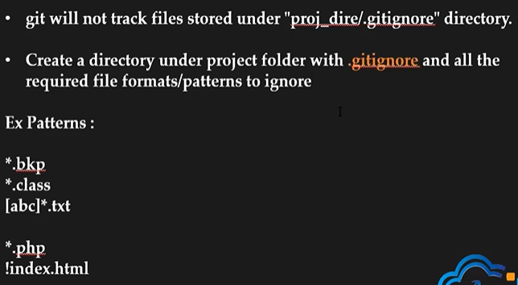

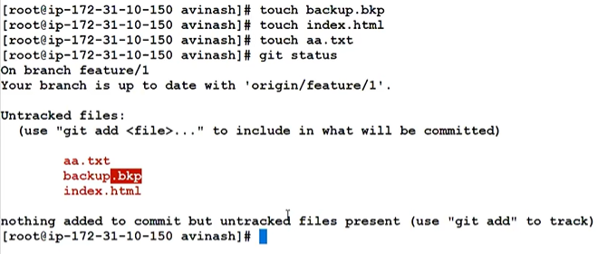

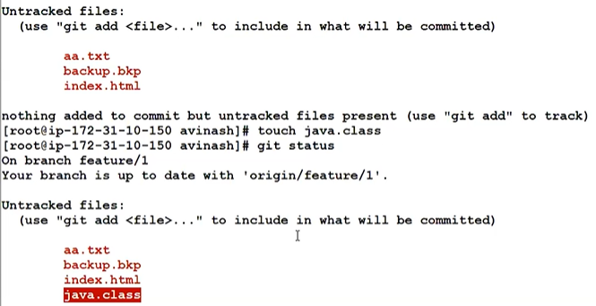

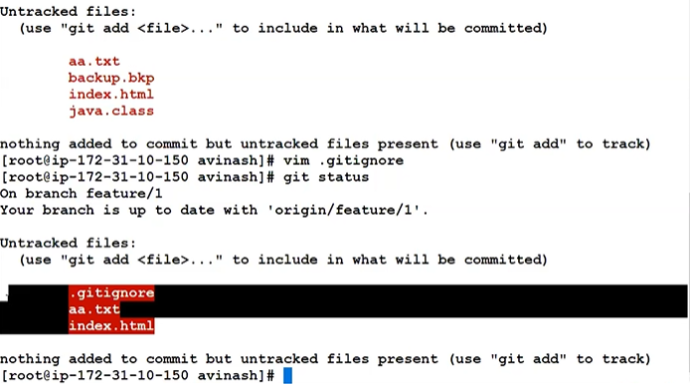

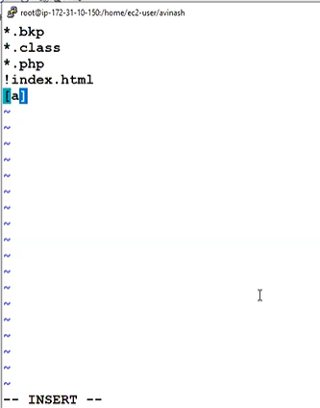

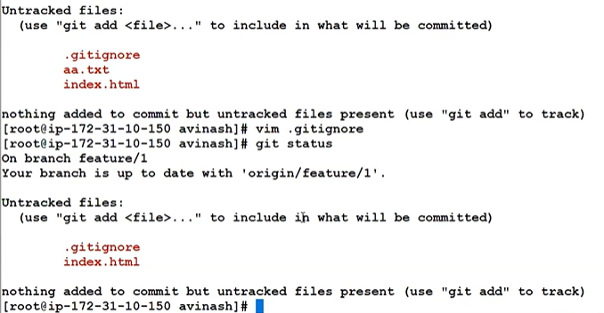

## 9. Github Signup and First Repo Creation

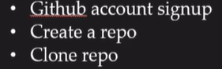

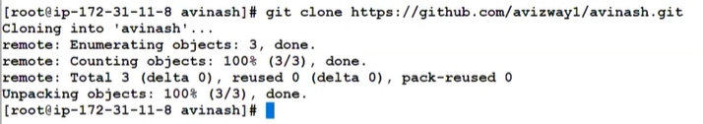

## 10. GIT Push Command

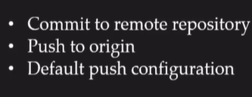

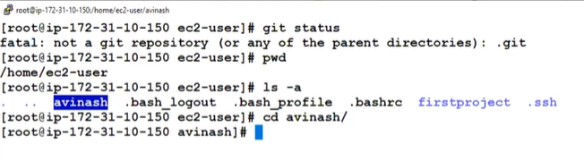

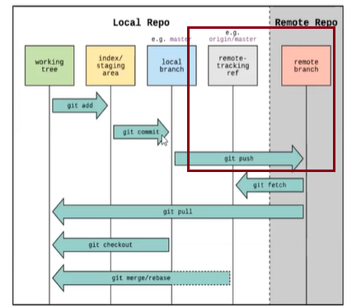

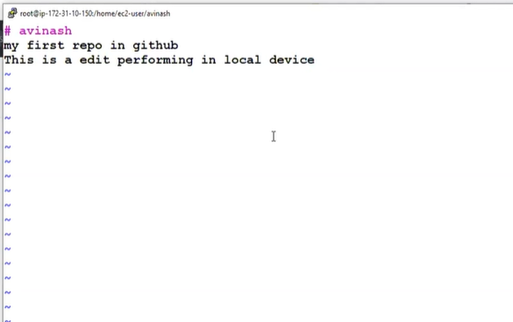

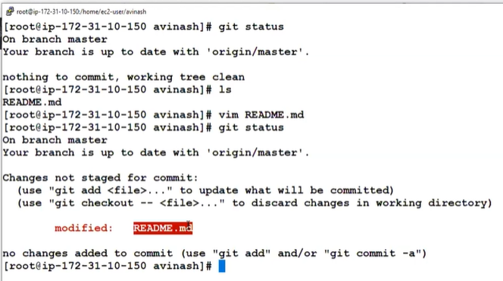

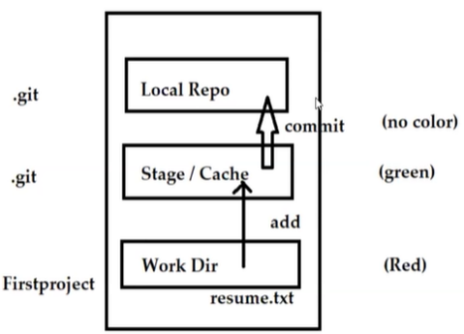

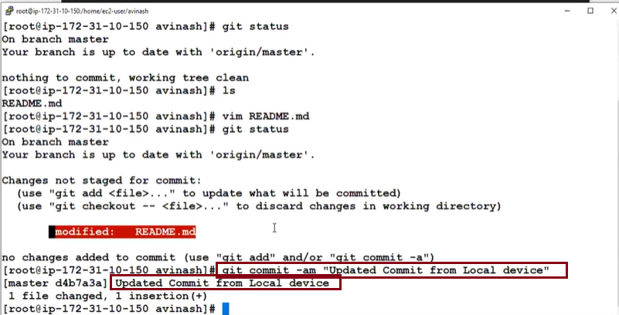

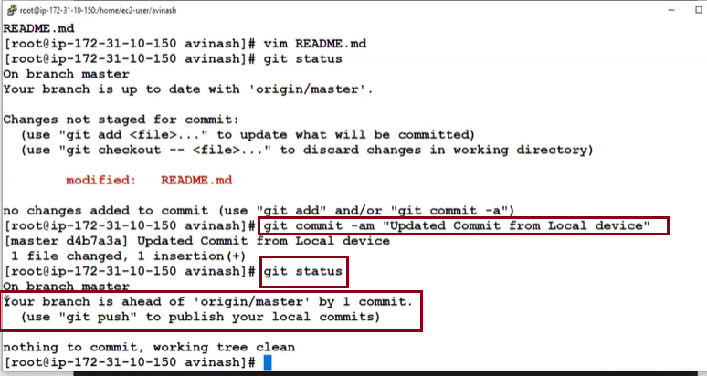

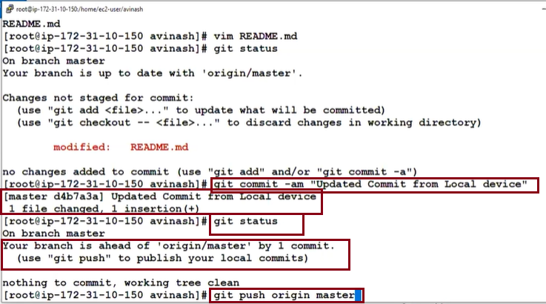

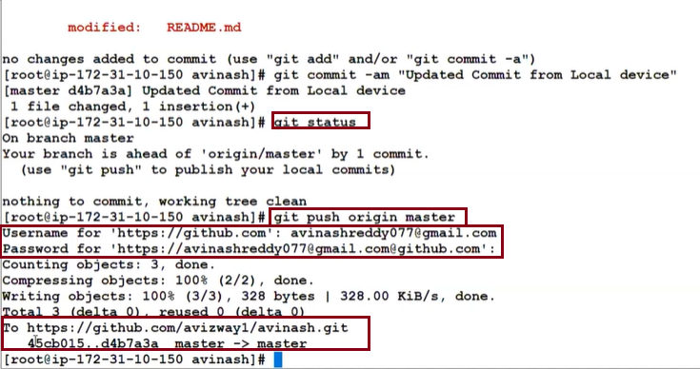

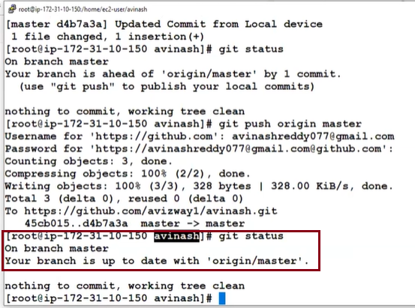

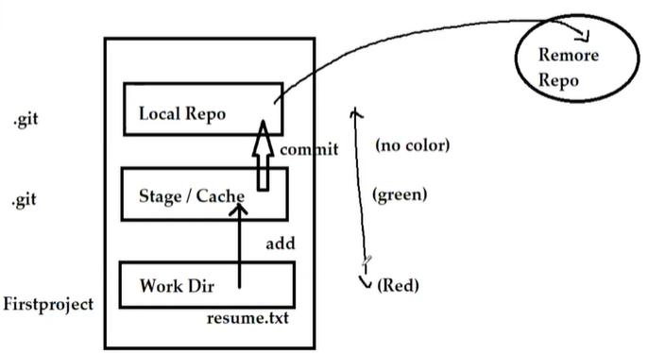

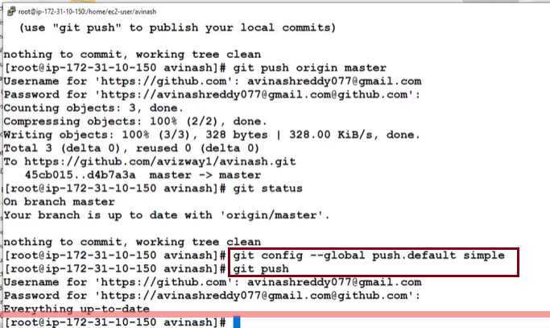

## 11. Adding and Removing Files

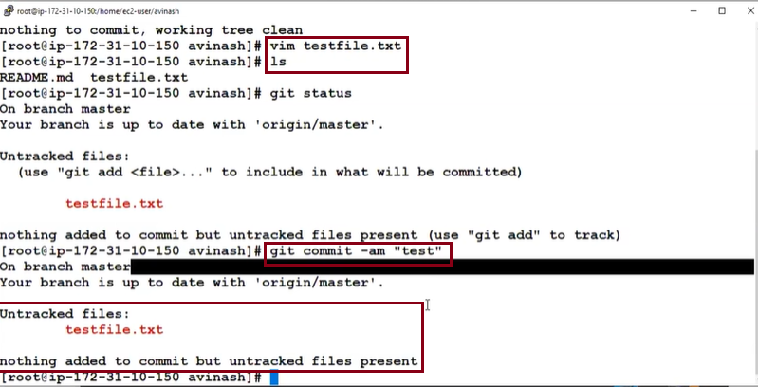

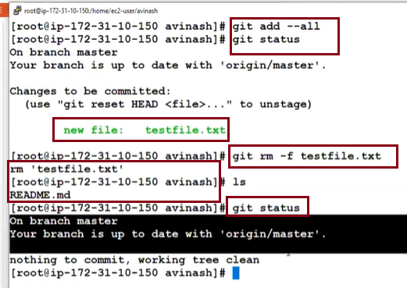

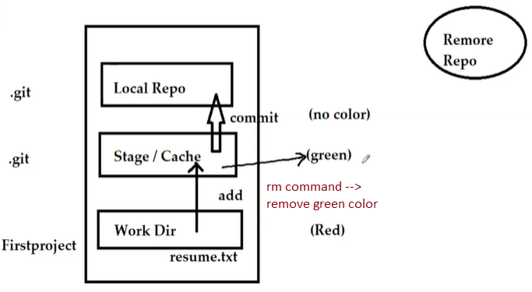

If it is in stage – rm is sufficient.

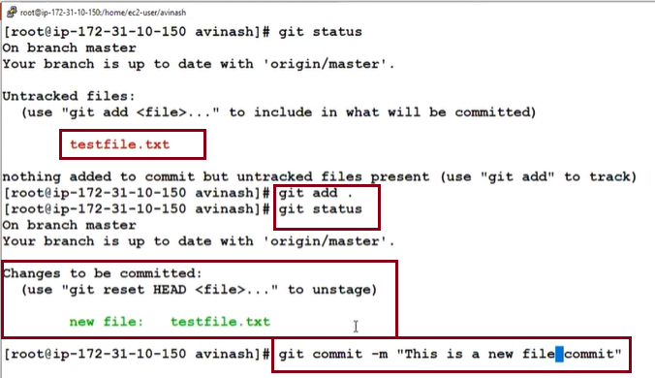

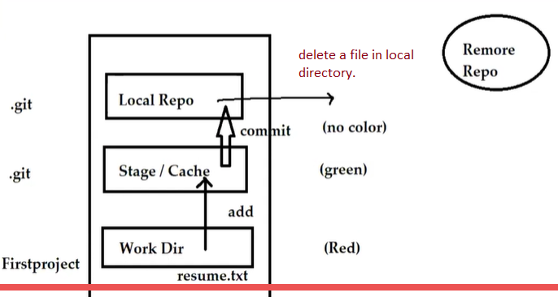

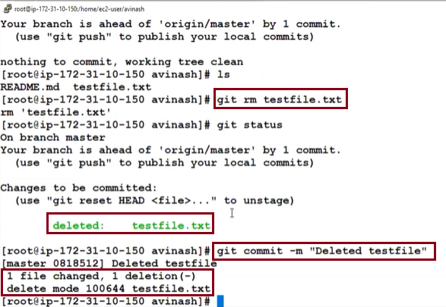

If it is in Local Repo **– rm and commit** command is sufficient.

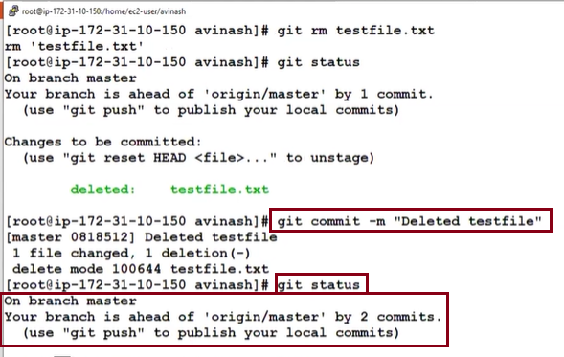

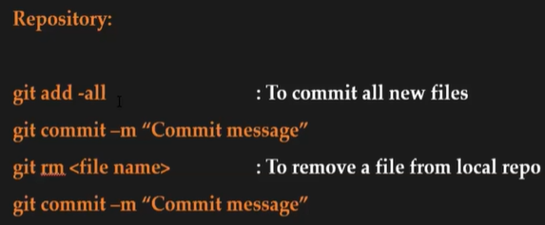

## 12. Pull Requests



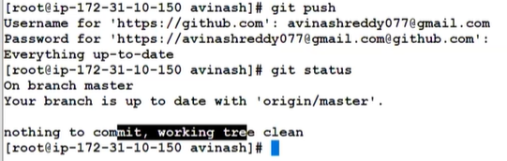

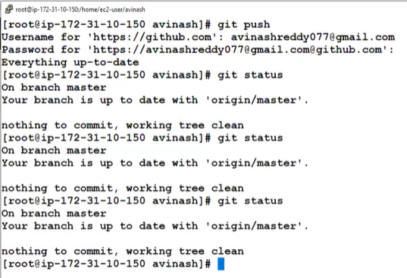

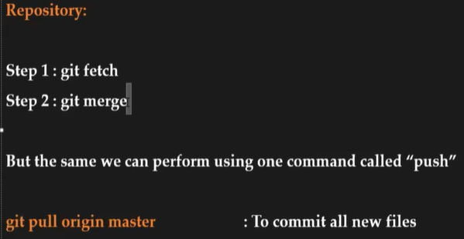



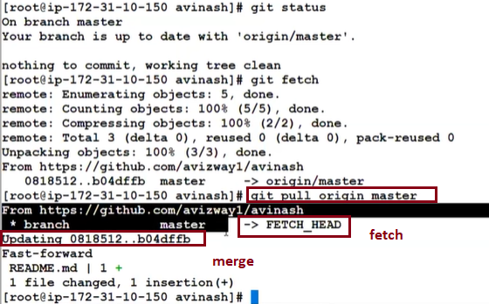

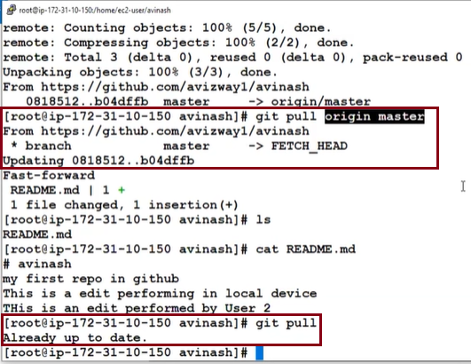

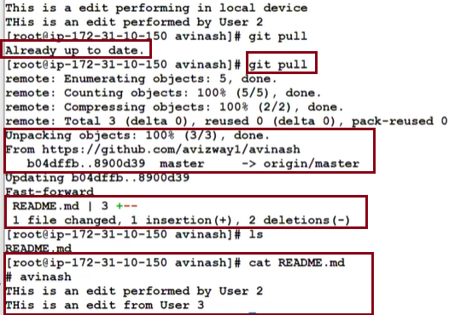

## 13. Branching

**Need to watch video…**

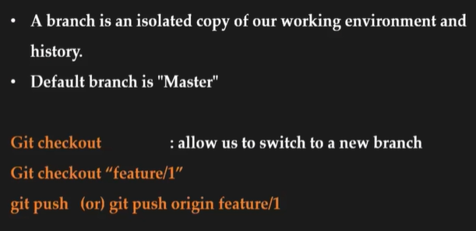

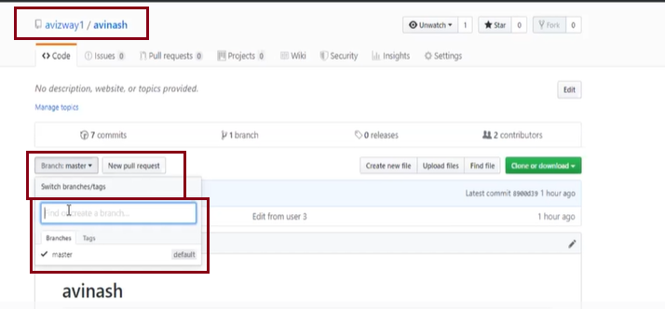

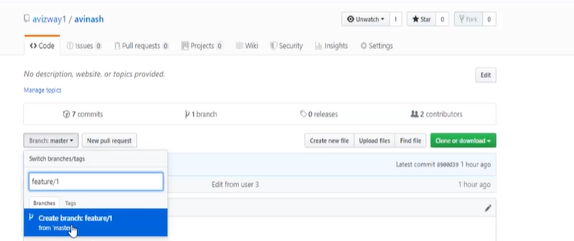

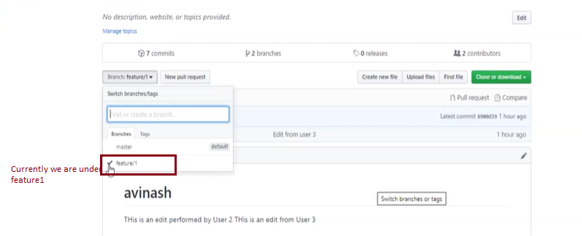

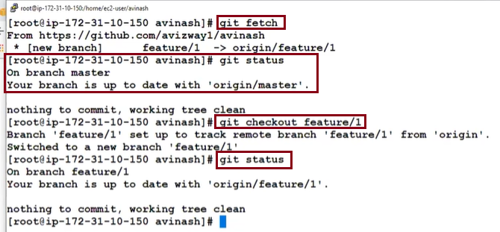

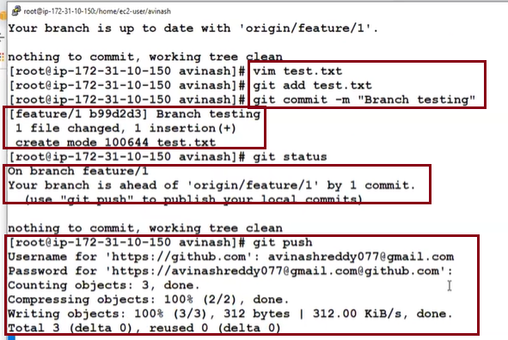

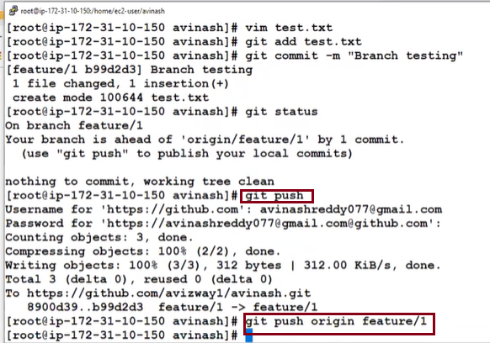

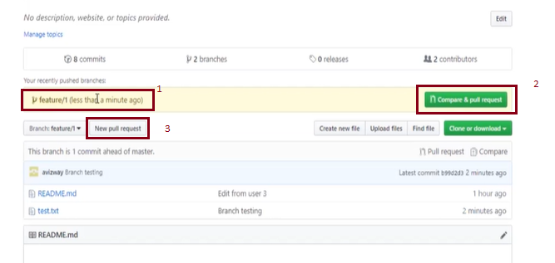

**New Pull request** will take you to here.

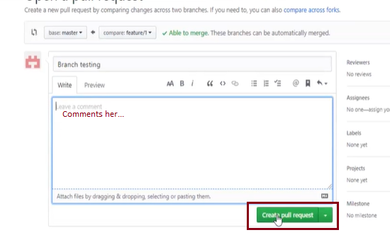

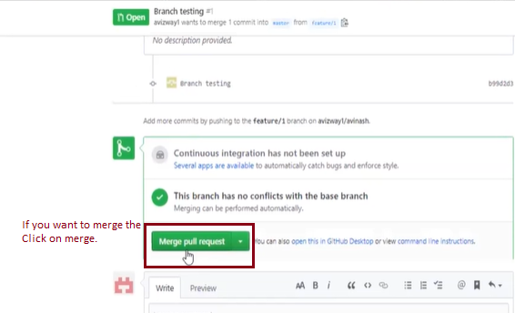

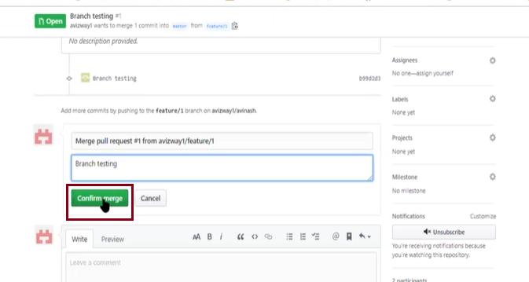

**Need to watch video…**

14. CICD with AWS Elastic Beanstalk

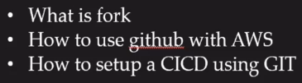

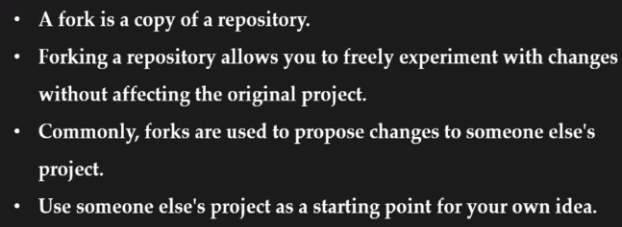

# <https://github.com/aws-samples/aws-codepipeline-s3-codedeploy-linux>

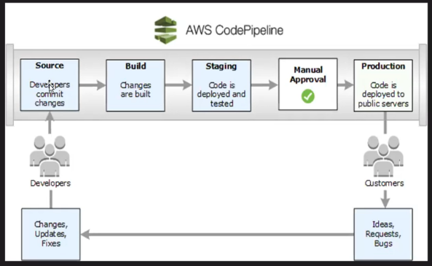

https://github.com/aws-samples/aws-codepipeline-s3-codedeploy-linux

https://github.com/search?q=org%3Aaws-samples+s3

https://github.com/aws-samples/s3-select-phonebook-search

**Need to watch video…**

## Git basics - Learn the basics of the GIT CLI

### 1. Part 1: The Basics

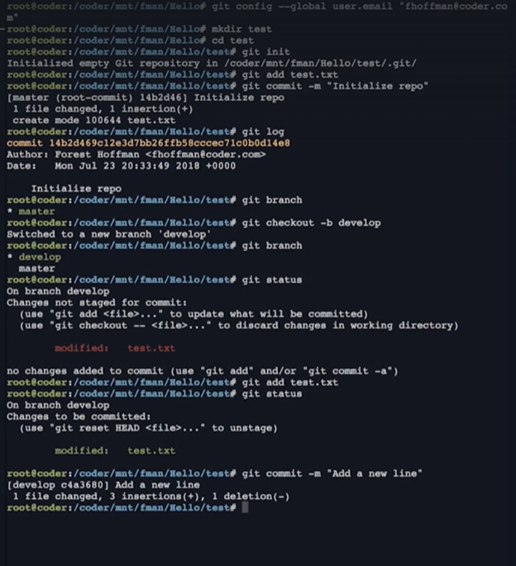

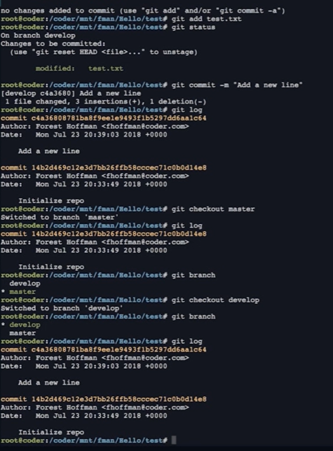

### 2. Part 2: Intermediate

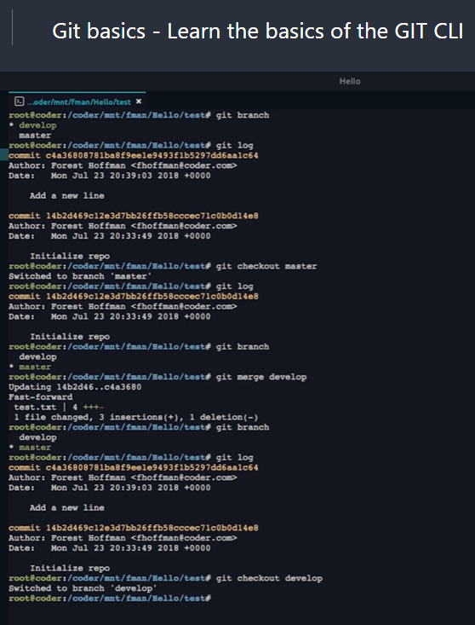

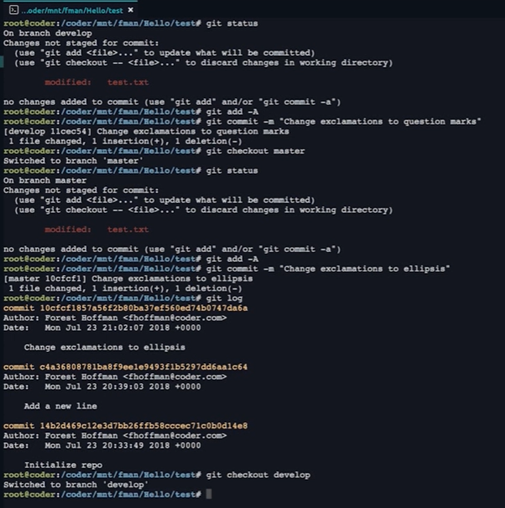

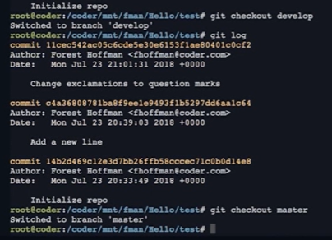

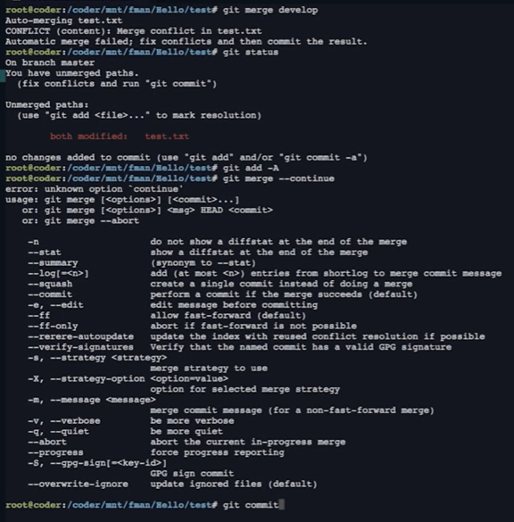

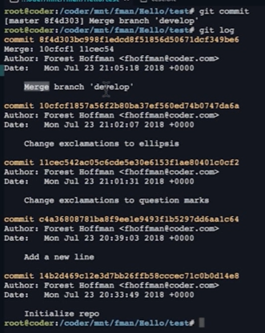

### 3. Part 3: Advanced

**Watch video**

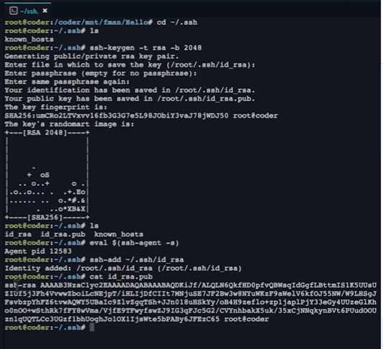

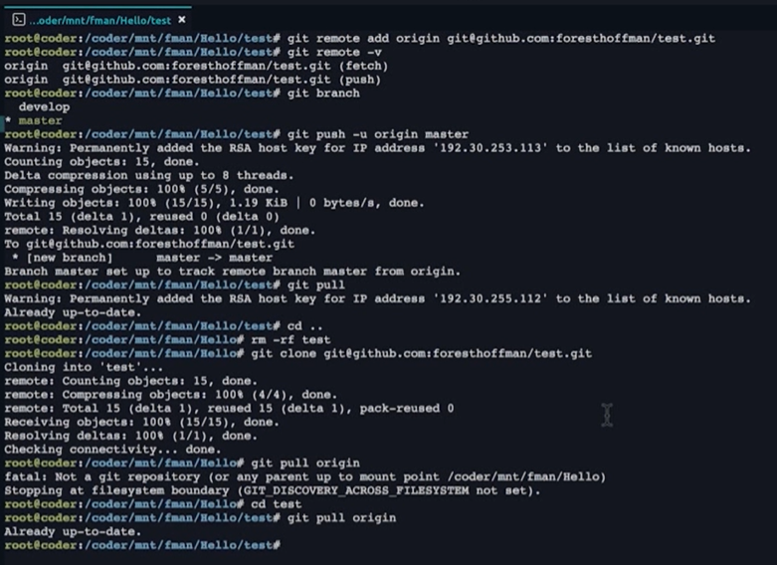

### 4. Part 4: Expert

**Reset – Previous changes.**

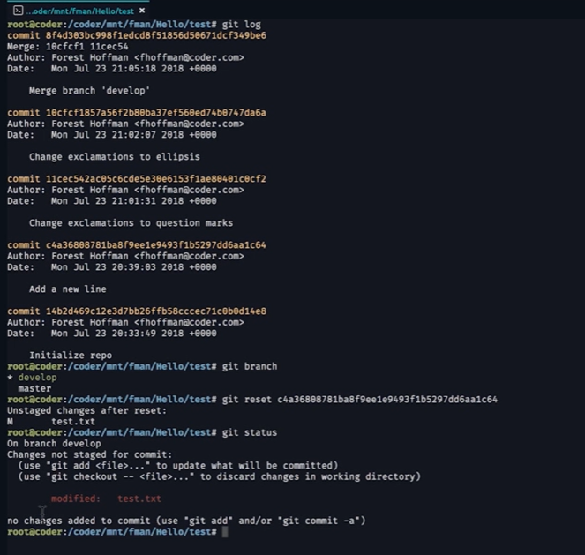

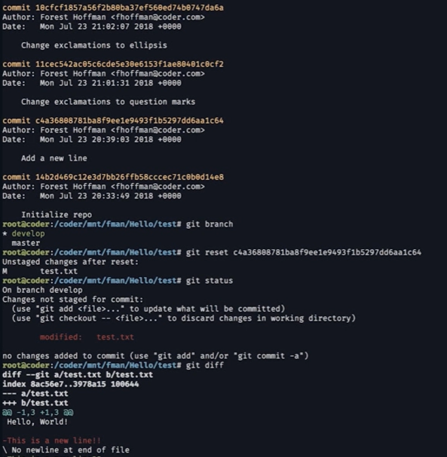

**Git reset HEAD-2 undo last 2 commits**

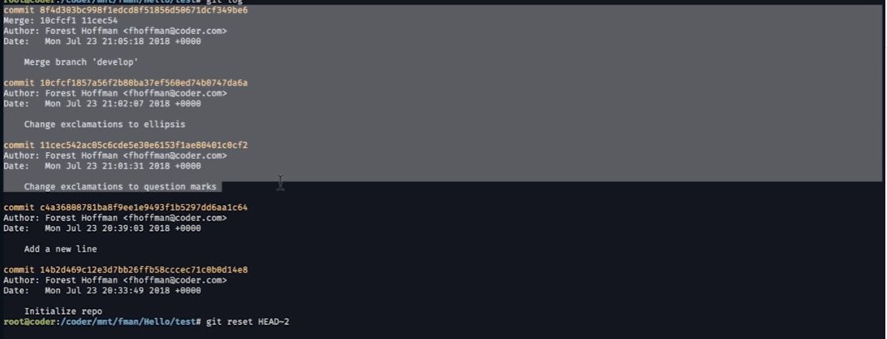

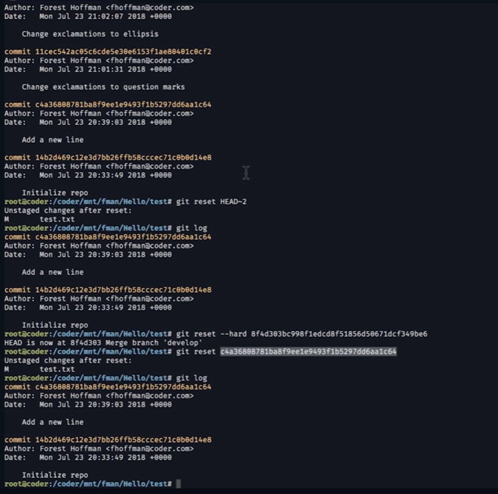

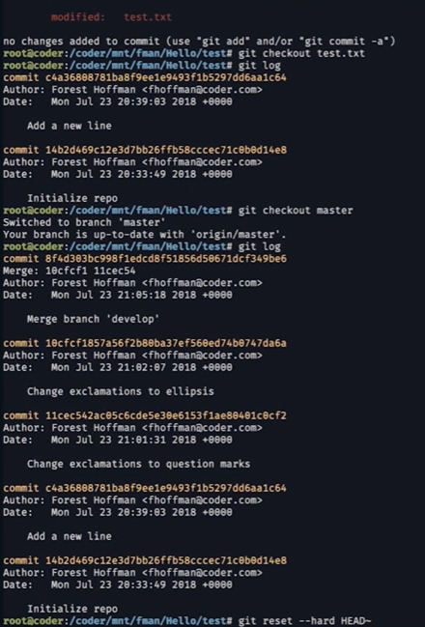

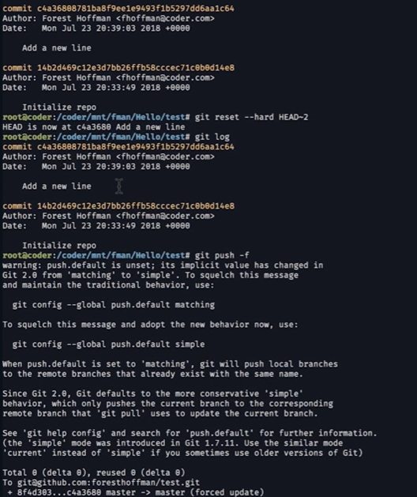

#### git reflog 🡪 tell you what all commands runs on.

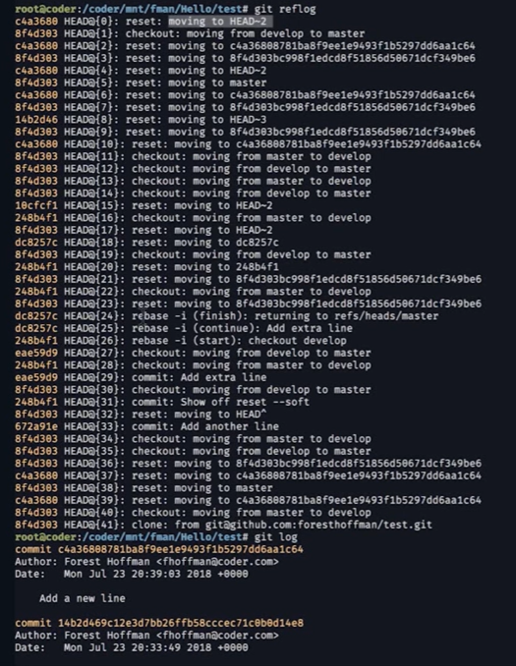

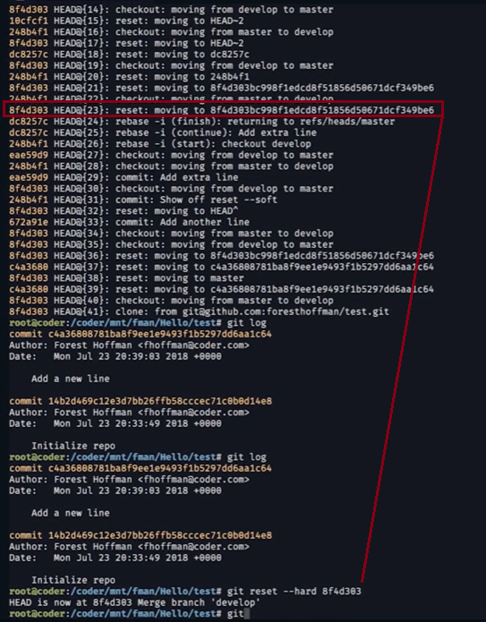

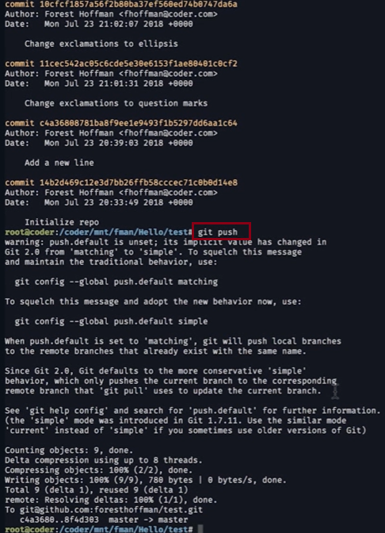

#### Git rebase –i HEAD -2

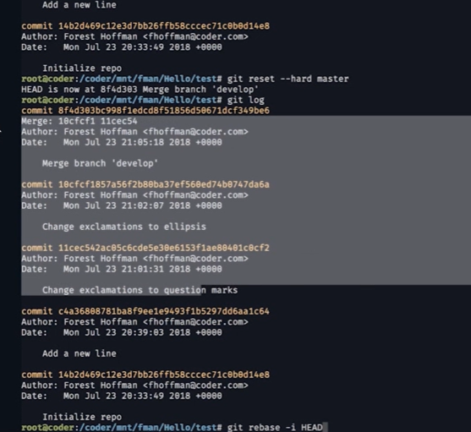

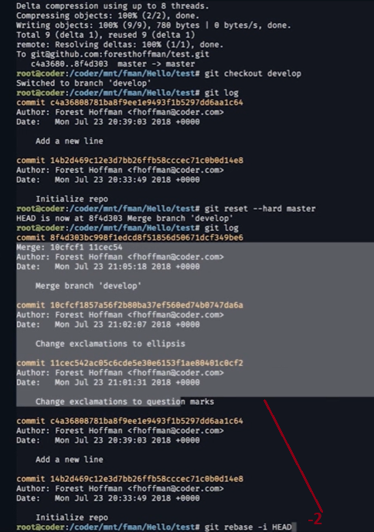

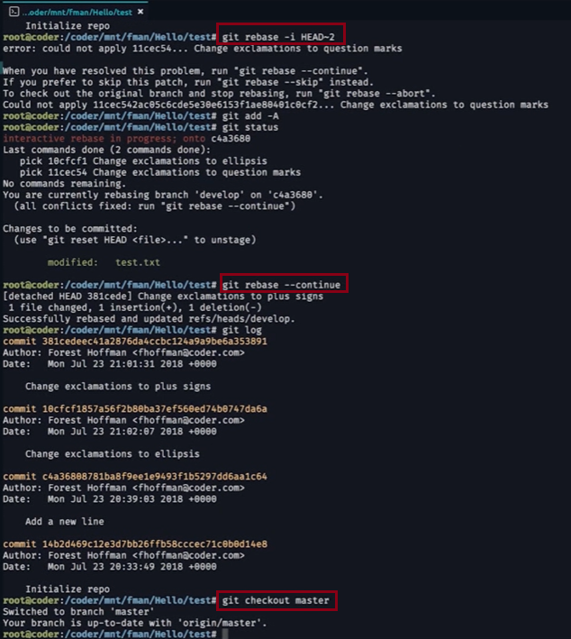

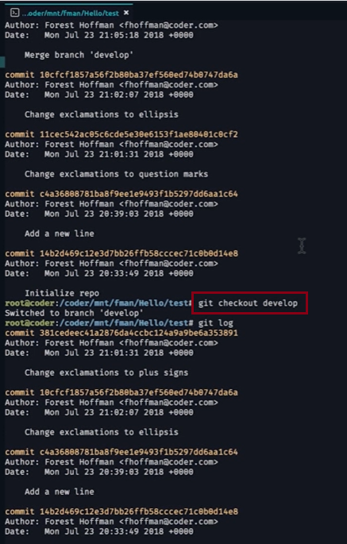

# Beginner

**What is version control**

Benefits of version control

Source Code Management

What is Git

Why Git for your Organization

Install Git

Git SSH

Git archive

GitOps

Git Cheatsheet

## What is version control

Version control systems are a **category of software tools that help a software team manage changes** to **source code over time.**

**Version control software keeps track of every modification to the code in a special kind of database**.

If a mistake is made, developers can turn back the clock and compare earlier versions of the code to help fix the mistake while minimizing disruption to all team members.

----------------------------------------------

Getting Started

Setting up a repository

git init

git clone

git config

git alias

Saving changes

git add

git commit

git diff

git stash

.gitignore

Inspecting a repository

git status

git tag

git blame

Undoing changes

git checkout

git clean

git revert

git reset

git rm

Rewriting history

git commit --amend

git rebase

git rebase -i

git reflog

_______________________________________

# Collaborating

Syncing

* git remote
* git fetch
* git push
* git pull

## git fetch

The **git fetch command downloads commits, files, and refs from a remote repository into your local repo**. Fetching is what you do when you want to see what everybody else has been working on. It’s **similar to svn update** in that it lets you see how the central.

Git fetch commands and options

### git fetch <remote>

Fetch all of the branches from the repository. This also downloads all of the required commits and files from the other repository.

### git fetch <remote><branch>

Same as the above command, but only fetch the specified branch.

### git fetch --all

A power move which fetches all registered remotes and their branches:

### git fetch --dry-run

The --dry-run option will perform a demo run of the command. I will output examples of actions it will take during the fetch but not apply them.

### Git fetch examples

git fetch a remote branch

The following example will demonstrate **how to fetch a remote branch and update your local working state to the remote contents.** In this example, lets assume there is a central repo origin which the local repository has been cloned from using the git clone command. Let us also assume an additional remote repository named coworkers_repo that contains a feature_branch which we will configure and fetch. With these assumptions set let us continue the example.

## git push

The **git push command is used to upload local repository content to a remote repository**. **Pushing is how you transfer commits from your local repository to a remote repo.**

### Git push usage

### git push <remote><branch>

Push the specified branch to <remote>, along with all of the necessary commits and internal objects. This creates a local branch in the destination repository. To prevent you from overwriting commits, Git won’t let you push when it results in a non-fast-forward merge in the destination repository.

### git push <remote> --force

Same as the above command, but force the push even if it results in a non-fast-forward merge. Do not use the --force flag unless you’re absolutely sure you know what you’re doing.

### git push <remote> --all

Push all of your local branches to the specified remote.

### git push <remote> --tags

Tags are not automatically pushed when you push a branch or use the --all option. The --tags flag sends all of your local tags to the remote repository.

### Git push discussion

git push is most commonly used to publish an upload local changes to a central repository. After a local repository has been modified a push is executed to share the modifications with remote team members.

The above diagram shows what happens when your local masterhas progressed past the central repository’s master and you

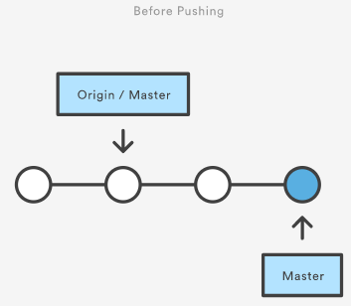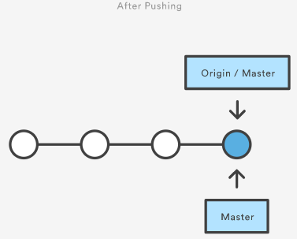

## git pull

The git pull command is **used to fetch and download content from a remote repository and immediately update the local repository to match that content.**

git pull will enter a merge workflow. A new merge commit will be-created and HEAD updated to point at the new commit.

### Git pull usage

### How it works

The git pull command first **runs git fetch which downloads content from the specified remote repository**. **Then a git merge is executed to merge the remote content refs and heads into a new local merge commit.** To better demonstrate the pull and merging process let us consider the following example. Assume we have a repository with a master branch and a remote origin.

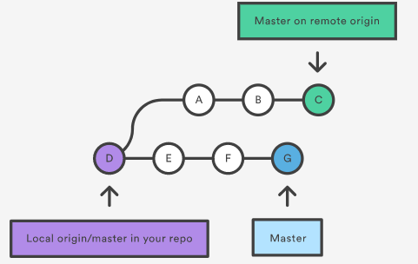

In this scenario, git pull will download all the changes from the point where the local and master diverged. In this example, that point is E. git pull will fetch the diverged remote commits which are A-B-C. The pull process will then create a new local merge commit containing the content of the new diverged remote commits.

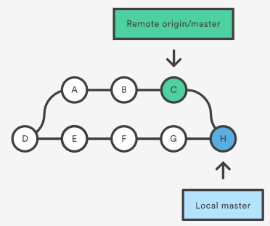

### git pull --rebase

In the above diagram, we can see the new commit H. This **commit is a new merge commit that contains the contents of remote A-B-C commits and has a combined log message**. This example is one of a **few git pull merging strategies**. **A --rebase option can be passed to git pull to use a rebase merging strategy instead of a merge commit**. The next example will demonstrate how a rebase pull works. Assume that we are at a starting point of our first diagram, and we have executed git pull --rebase.

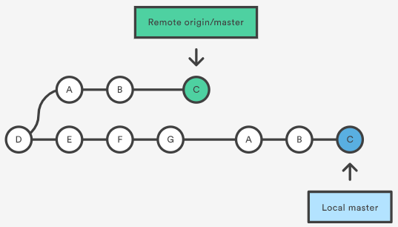

In this diagram, we can now see that a rebase pull does not create the new H commit. Instead, the rebase has copied the remote commits A--B--C and appended them to the local origin/master commit history.

### Common Options

### git pull <remote>

Fetch the specified remote’s copy of the current branch and immediately merge it into the local copy. This is the same as git fetch <remote> followed by git merge origin/<current-branch>.

### git pull --no-commit <remote>

Similar to the default invocation, fetches the remote content but does not create a new merge commit.

### git pull --rebase <remote>

Same as the previous pull Instead of using **git merge to integrate the remote branch with the local one, use git rebase.**

### git pull --verbose

Gives verbose output during a pull which displays the content being downloaded and the merge details.

### Git pull discussion

You can think of git pull as Git's version of svn update. It’s an easy way to synchronize your local repository with upstream changes. The following diagram explains each step of the pulling process.

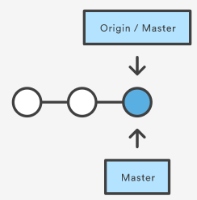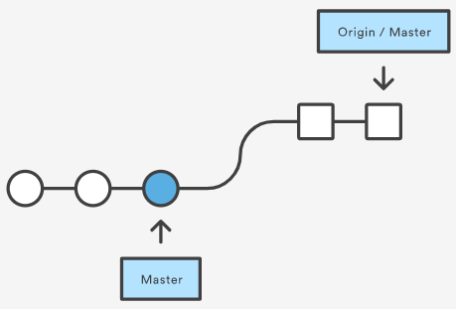

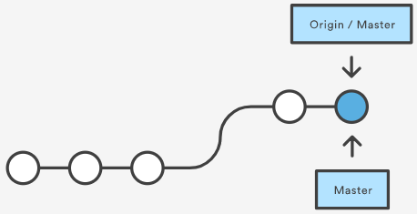

You start out thinking your repository is synchronized, but then git fetch reveals that origin's version of master has progressed since you last checked it. Then git merge immediately integrates the remote master into the local one.

### Git pull and syncing

git pull is one of many commands that claim the responsibility of 'syncing' remote content. The git remote command is used to specify what remote endpoints the syncing commands will operate on. The git push command is used to upload content to a remote repository.

The git fetch command can be confused with git pull. They are both used to download remote content. An important safety distinction can me made between git pull and get fetch. git fetch can be considered the "safe" option whereas, git pull can be considered unsafe. git fetch will download the remote content and not alter the state of the local repository. Alternatively, git pull will download remote content and immediately attempt to change the local state to match that content. This may unintentionally cause the local repository to get in a conflicted state.

### Pulling via Rebase

The **--rebase option can be used to ensure a linear history by preventing unnecessary merge commits**. Many developers prefer rebasing over merging, since it’s like saying, **"I want to put my changes on top of what everybody else has done." In this sense, using git pull with the --rebase flag is even more like svn update than a plain git pull.**

In fact, pulling with --rebase is such a common workflow that there is a dedicated configuration option for it:

#### git config --global branch.autosetuprebase always

After running that command, all git pull commands will integrate via git rebase instead of git merge.

### Git Pull Examples

The following examples demonstrate how to use git pull in common scenarios:

## Default Behavior : git pull

Executing the default invocation of git pull will is equivalent to git fetch origin HEAD and git merge HEAD where HEAD is ref pointing to the current branch.

### Git pull on remotes : git checkout new_feature : git pull <remote repo>

This example first performs a checkout and switches to the <newfeature> branch. Following that, the git pull is executed with <remote repo> being passed. This will implicitly pull down the newfeature branch from <remote repo>. Once the download is complete it will initiate a git merge.

### Git pull rebase instead of merge

The following example demonstrates how to synchronize with the central repository's master branch using a rebase:

### git checkout master : git pull --rebase origin

This simply moves your local changes onto the top of what everybody else has already contributed.

Using branches

git branch

git checkout

git merge

Merge conflicts

Merge strategies

Comparing workflows

Centralized Workflow

Feature Branch Workflow

Gitflow Workflow

Forking Workflow

_______________________________________

Advanced Tips

Advanced Git Tutorials

Merging vs. Rebasing

Resetting, Checking Out, and Reverting

Advanced Git log

Git Hooks

Refs and the Reflog

Git submodules

Git subtree

Large repositories in Git

Git LFS

Git gc

Git prune

Git Bash

How to store dotfiles

Git Cherry Pick

GitK

Git-show

________________________________________

Migrating to Git

SVN to Git - prepping for the migration

For administrators

Basic Git commands

Git Migration Tools

For developers

Migrate to Git from SVN

Prepare

Convert

Synchronize

Share

Migrate

Perforce to Git - why to make the move

Migrating from Perforce to Git

How to move a Git repository with history

# 8 Reasons Bitbucket is Better than GitHub

**1. Bitbucket is more flexible than GitHub**

While GitHub comes with a lot of features and **allows you to**[**create your own workflows**](https://www.idalko.com/jira-workflow-best-practices/), BitBucket has more **flexibility built-in.**

For example, BitBucket gives you **more options about the version control system that you use** (incorporating Mercurial as well as Git).

**BitBucket** can also **import from Git, CodePlex, Google Code, HG, SourceForge, and SVN**. While **GitHub is limited** to Git, SVN, HG, and TFS.

**2. Bitbucket gives you unlimited private repositories**

Having a single account on a single platform makes managing things far, far easier.

In this respect, **BitBucket works for you, allowing you to have as many private repositories as you want.**

And you can share them with five collaborators for free.

This allows you to separate personal and business projects.

You can also separate your work for different clients without the hassle or unnecessary management.

Given the potential value of your code, this is extremely important – and BitBucket makes it simple.

**3. Bitbucket has better pricing for private work**

Yes, Github is considered to be free. But that’s only if you allow your work to be public.

If you want to have any private repositories at all on GitHub, you’ll have to cough up some cash.

Have a look at the pricing comparison:

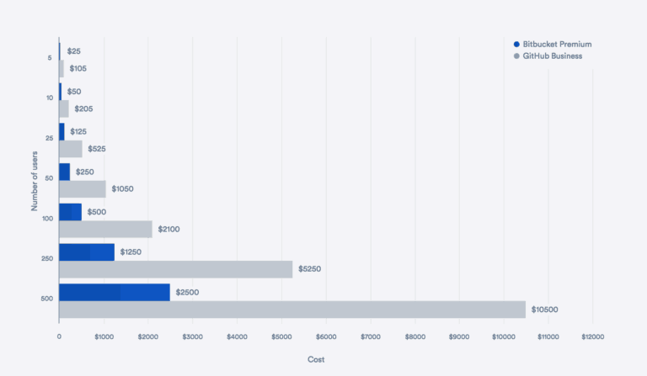

**BitBucket, on the other hand, is totally free for up to five users.** This includes the **unlimited private repositories we just mentioned. Given that you can have unlimited public repositories as well, it’s hardly surprising that there are a number of large open-source projects on the platform.**

BitBucket also offers unlimited private repositories to teachers and students for free – which is a hard price to say no to.

**4. Continuous Integration / Delivery is built-in by default**

With BitBucket, Continuous Integration and Delivery is tied into your source code from the get-go. That **means there is far less setup and management needed when it comes to users, repositories, and servers.**

That doesn’t apply when it comes to GitHub – meaning everything has to be set up on a case-by-case basis and information ends up being siloed in different tools.

**5. Bitbucket is trustworthy**

It seems commentators are skeptical about precisely what Microsoft’s interest is in GitHub.

In fact, it may very well be the fact that Github offers access to an enormous ecosystem of developers and what is effectively a coders’ social network. This is particularly important as it still sits outside the purview of LinkedIn – another recent Microsoft acquisition.

This was apparent after the huge spike in migrations of repositories to Bitbucket, straight after the announcement that Microsoft acquired Github:

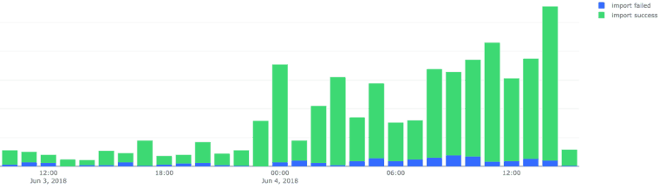

BitBucket has been part of the Atlassian family since 2010 and is a major part of its offering for the engineering community.

Given this, it’s unlikely that they’ll be looking to rock the boat or to squeeze the product for revenue. And there’s no reason that that situation will change any time soon.

**6. Smarter semantic searching**

The little things can make all the difference. BitBucket’s search crawls your syntax to find definitions that match your query, rather than just variable names.

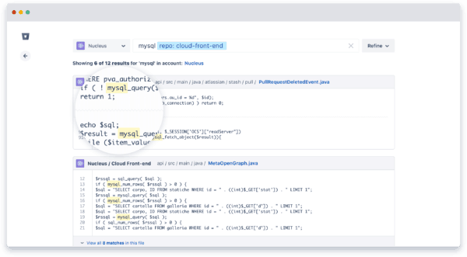

That makes search far faster and more powerful than it would otherwise be. And isn’t that what good software is meant to do?

**7. Bitbucket has a powerful Jira integration**

“Atlassian is to software what Apple is to design” – FORBES

Ever since Atlassian went public in 2017 with an estimated market value of +10 Billion USD, the exponential growth of its product suite seems virtually unstoppable. And Jira is their flagship product.

Jira was originally built as bug trackers but is so flexible now it can be used for: bug tracking, issue tracking, service desks, and project management.

Note: Learn more about Jira by downloading our [Intuitive Jira Guide for Users](https://www.idalko.com/jira-guide/).

**BitBucket integrates seamlessly with the Jira task tracking tool** (unsurprisingly given that both are owned by Atlassian).

**If you use the two tools together you can set code commits to automatically update Jira issues.**

And you can create branches straight from Jira – enabling fast, fluid workflows. This is one of BitBucket’s biggest benefits, tying the entire development process together with a set of integrated, synchronized tools.

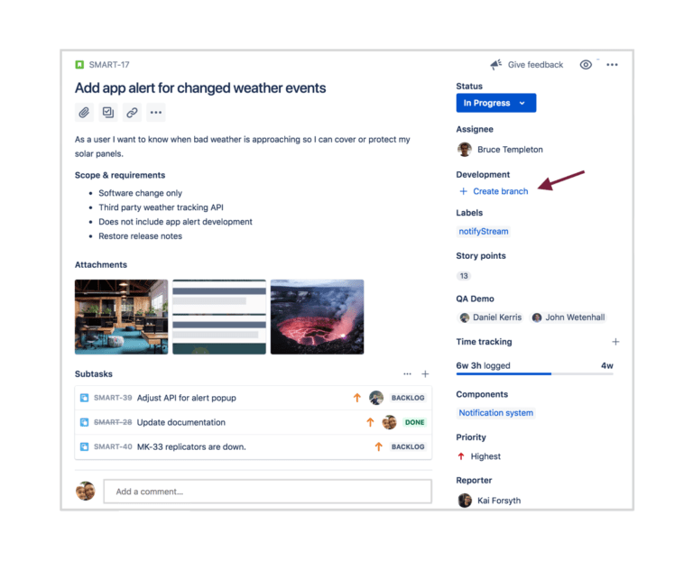

Even better, the integration can be set up in a matter of seconds. And who doesn’t want code deployment and task tracking working in perfect harmony?

**8. Bitbucket has a powerful Trello integration**

BitBucket even comes with an easy-to-use Trello account, if you don’t want to get into Jira for whatever reason.

Because, yes, [Trello](https://www.idalko.com/trello-guide/) is also part of the Atlassian software family.

[*Here*](https://www.idalko.com/jira-better-trello-even-non-developers/) you can read why Jira is better than Trello (even for non-developers)

**Downsides to BitBucket**

I know it seems I have been picking on Github a bit in this post. But, needless to say, it does have its strengths.

So to bring some nuance to my arguments, I’ll grant Github the following strengths:

**1. Community**

It’s hard to argue that GitHub is more universal than BitBucket – and it brings a bustling development community with it. That’s also augmented by easy-to-use tools for finding and sharing code. However, GitHub’s currently leading status isn’t one that it’ll necessarily stay the same forever.

**2. Plugins**

While there’s plenty going on on BitBucket – and there are plenty of native plugins available to extend the platform – GitHub comes ahead in this category.

That said, BitBucket does have some great apps.

And [Bitbucket Connect](https://developer.atlassian.com/blog/2016/02/bitbucket-connect-in-golang/) makes deep integrations simple.

One example of a great BitBucket app is SourceTree, created by Atlassian, which provides a graphical interface and visualizations for your projects.

There’s also the [Slack](https://slack.com/) app – which allows you to pull information and comment, merge and prompt code reviews, all from within the channel.

What’s more, if you look at the wider landscape of the Atlassian Marketplace, there is an absolutely huge range of apps available that can help you work via other Atlassian products.

**Conclusion**

To summarize the benefits that we’ve discussed, BitBucket:

Is absolutely more flexible – with access to a wider range of version control systems

Has a powerful Jira integration – to make task tracking simple

Has a powerful Trello integration

Gives you unlimited private repositories for free, for up to 5 users (and unlimited public repositories at no extra cost)

Arguably has better pricing, depending on your needs

Has continuous integration and delivery built-in

Has smarter semantic searching

And isn’t part of a larger Silicon Valley power play! ;D

If you are looking for an alternative to GitHub, or are looking for a more flexible code repository, then BitBucket may well be the start and the end of your search.

Equally, with a small team, the BitBucket pricing structure may make more sense for you.

And if you use Jira for task tracking already, then plugging in BitBucket is a simple step to coding nirvana.

# Git Stash

Sometimes you **want to switch the branches**, but **you are working on an incomplete part of your current project.** You don't want to make a commit of half-done work. Git stashing allows you to do so. The **git stash command** enables you to switch branches without committing the current branch.

The below figure demonstrates the properties and role of stashing concerning repository and working directory.

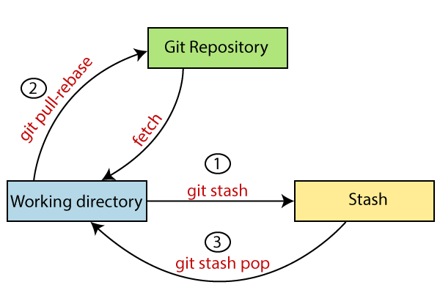

Generally, the stash's meaning is "**store something safely in a hidden place**." The sense in Git is also the same for stash; Git temporarily saves your data safely without committing.

Stashing takes the messy state of your working directory, and temporarily save it for further use. Many options are available with git stash. Some useful options are given below:

* **Git stash**
* **Git stash save**
* **Git stash list**
* **Git stash apply**
* **Git stash changes**
* **Git stash pop**
* **Git stash drop**
* **Git stash clear**
* **Git stash branch**

## Stashing Work

Let's understand it with a real-time scenario. I have made changes to my project GitExample2 in two files from two distinct branches. I am in a messy state, and I have not entirely edited any file yet. So I want to save it temporarily for future use. We can stash it to save as its current status. To stash, let's have a look at the repository's current status. To check the current status of the repository, run the git status command. The git status command is used as:

**Syntax:**

1. $ git status

**Output:**

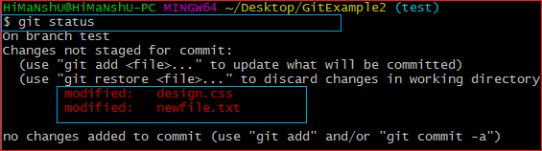

From the above output, you can see the status that there are two untracked file **design.css** and **newfile.txt** available in the repository. To save it temporarily, we can use the git stash command. The git stash command is used as:

**Syntax:**

1. $ git stash

**Output:**

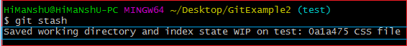

In the given output, the work is saved with git stash command. We can check the status of the repository.

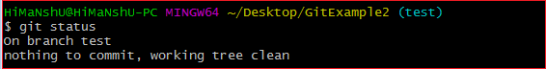

As you can see, my work is just stashed in its current position. Now, the directory is cleaned. At this point, you can switch between branches and work on them.

## Git Stash Save (Saving Stashes with the message):

In Git, the changes can be stashed with a message. To stash a change with a message, run the below command:

**Syntax:**

1. $ git stash save "**<Stashing** Message**>**"

**Output:**



The above stash will be saved with a message

## Git Stash List (Check the Stored Stashes)

To check the stored stashes, run the below command:

**Syntax:**

1. $ git stash list

**Output:**

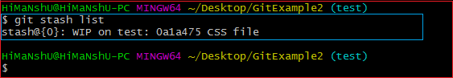

In the above case, I have made one stash, which is displayed as "**stash@{0}: WIP on the test: 0a1a475 CSS file**".

If we have more than one stash, then It will display all the stashes respectively with different stash id. Consider the below output:

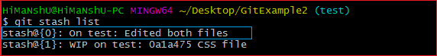

It will show all the stashes with indexing as **stash@{0}: stash@{1}:** and so on.

## Git Stash Apply

You can re-apply the changes that you just stashed by using the git stash command. To apply the commit, use the git stash command, followed by the apply option. It is used as:

**Syntax:**

1. $ git stash apply

**Output:**

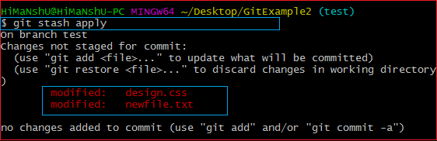

The above output restores the last stash. Now, if you will check the status of the repository, it will show the changes that are made on the file. Consider the below **output:**

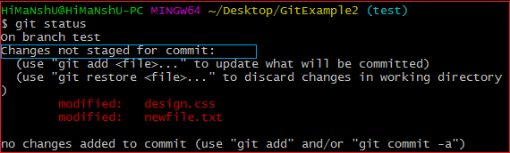

From the above output, you can see that the repository is restored to its previous state before stash. It is showing output as "**Changes not staged for commit**."

In case of more than one stash, you can use "git stash apply" command followed by stash index id to apply the particular commit. It is used as:

**Syntax:**

1. $ git stash apply **<stash** id**>**

Consider the below output:

**Output:**

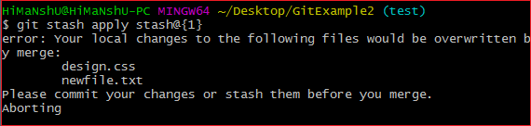

If we don't specify a stash, Git takes the most recent stash and tries to apply it.

## Git Stash Changes

We can track the stashes and their changes. To see the changes in the file before stash and after stash operation, run the below command:

**Syntax:**

1. $ git stash show

The above command will show the file that is stashed and changes made on them. Consider the below output:

**Output:**

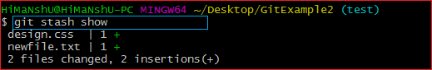

The above output illustrates that there are two files that are stashed, and two insertions performed on them.

We can exactly track what changes are made on the file. To display the changed content of the file, perform the below command:

**Syntax:**

1. $ git stash show -p

Here, -p stands for the partial stash. The given command will show the edited files and content, consider the below output:

**Output:**

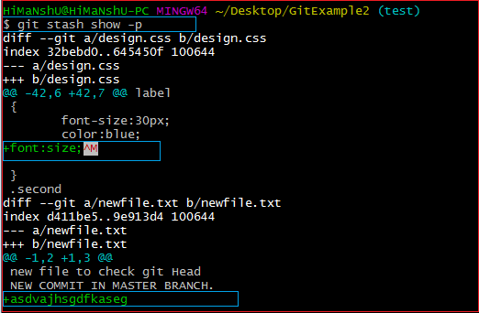

The above output is showing the file name with changed content. It acts the same as git diff command. The **git diff** command will also show the exact output.

## Git Stash Pop (Reapplying Stashed Changes)

Git allows the user to re-apply the previous commits by using git stash pop command. The popping option removes the changes from stash and applies them to your working file.

The git stash pop command is quite similar to git stash apply. The main difference between both of these commands is stash pop command that deletes the stash from the stack after it is applied.

**Syntax:**

1. $ git stash pop

The above command will re-apply the previous commits to the repository. Consider the below output.

**Output:**

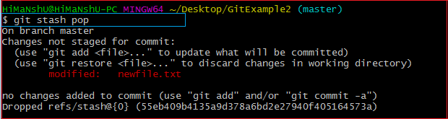

## Git Stash Drop (Unstash)

The **git stash drop** command is used to delete a stash from the queue. Generally, it deletes the most recent stash. Caution should be taken before using stash drop command, as it is difficult to undo if once applied.

The only way to revert it is if you do not close the terminal after deleting the stash. The stash drop command will be used as:

**Syntax:**

1. $ git stash drop

**Output:**

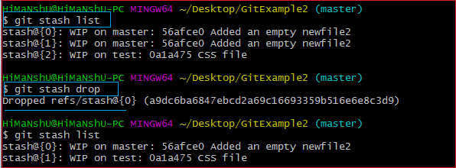

In the above output, the most recent stash **(stash@{0})** has been dropped from given three stashes. The stash list command lists all the available stashes in the queue.

We can also delete a particular stash from the queue. To delete a particular stash from the available stashes, pass the stash id in stash drop command. It will be processed as:

**Syntax:**

1. $ git stash drop **<stash** id**>**

Assume that I have two stashes available in my queue, and I don't want to drop my most recent stash, but I want to delete the older one. Then, it will be operated as:

1. $ git stash drop stash@{1}

Consider the below output:

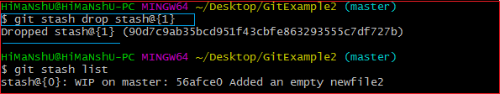

In the above output, the commit **stash@{1}** has been deleted from the queue.

## Git Stash Clear

The **git stash clear** command allows deleting all the available stashes at once. To delete all the available stashes, operate below command:

**Syntax:**

1. $ git stash clear

it will delete all the stashes that exist in the repository.

**Output:**

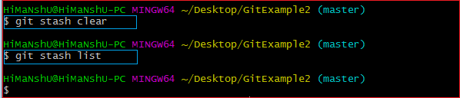

All the stashes are deleted in the above output. The git stash list command is blank because there are no stashes available in the repository.

## Git Stash Branch

If you stashed some work on a particular branch and continue working on that branch. Then, it may create a conflict during merging. So, it is good to stash work on a separate branch.

The git stash branch command allows the user to stash work on a separate branch to avoid conflicts. The syntax for this branch is as follows:

**Syntax:**

1. $ git stash branch **<Branch** Name**>**

The above command will create a new branch and transfer the stashed work on that. Consider the below output:

**Output:**

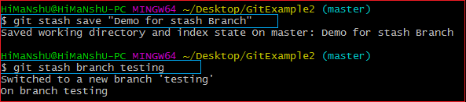

In the above output, the stashed work is transferred to a newly created branch testing. It will avoid the merge conflict on the master branch.

# Git Rebase

Rebasing is a process to reapply commits on top of another base trip. It is used to apply a sequence of commits from distinct branches into a final commit. It is an alternative of git merge command. It is a linear process of merging.

In Git, the term rebase is referred to as the process of moving or combining a sequence of commits to a new base commit. Rebasing is very beneficial and it visualized the process in the environment of a feature branching workflow.

It is good to rebase your branch before merging it.

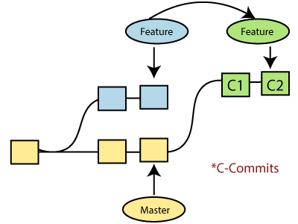

Generally, it is an alternative of git merge command. Merge is always a forward changing record. Comparatively, rebase is a compelling history rewriting tool in git. It merges the different commits one by one.

Suppose you have made three commits in your master branch and three in your other branch named test. If you merge this, then it will merge all commits in a time. But if you rebase it, then it will be merged in a linear manner. Consider the below image:

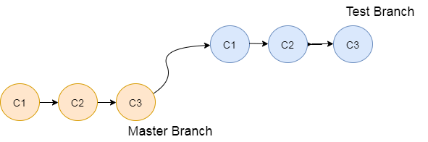

The above image describes how git rebase works. The three commits of the master branch are merged linearly with the commits of the test branch.

Merging is the most straightforward way to integrate the branches. It performs a three-way merge between the two latest branch commits.

## How to Rebase

When you made some commits on a feature branch (test branch) and some in the master branch. You can rebase any of these branches. Use the git log command to track the changes (commit history). Checkout to the desired branch you want to rebase. Now perform the rebase command as follows:

**Syntax:**

1. $git rebase **<branch** name**>**

If there are some conflicts in the branch, resolve them, and perform below commands to continue changes:

1. $ git status

It is used to check the status,

1. $git rebase --continue

The above command is used to continue with the changes you made. If you want to skip the change, you can skip as follows:

1. $ git rebase --skip

When the rebasing is completed. Push the repository to the origin. Consider the below example to understand the git merge command.

Suppose that you have a branch say **test2** on which you are working. You are now on the test2 branch and made some changes in the project's file **newfile1.txt**.

Add this file to repository:

1. $ git add newfile1.txt

Now, commit the changes. Use the below command:

1. $ git commit -m "new commit for test2 branch."

The output will look like:

[test2 a835504] new commitfor test2 branch

1 file changed, 1 insertion(+)

Switch the branch to master:

1. $ git checkout master

**Output:**

Switched to branch 'master.'

Your branch is up to date with 'origin/master.'

Now you are on the master branch. I have added the changes to my file, says **newfile.txt**. The below command is used to add the file in the repository.

1. $ git add newfile.txt

Now commit the file for changes:

1. $ git commit -m " new commit made on the master branch."

**Output:**

[master 7fe5e7a] new commit made on master

1 file changed, 1 insertion(+)

HiMaNshU@HiMaNshU-PC MINGW64 ~/Desktop/GitExample2 (master)

To check the log history, perform the below command.

1. $ git log --oneline

**Output:**

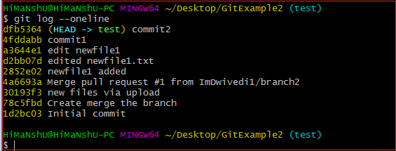

As we can see in the log history, there is a new commit in the master branch. If I want to rebase my test2 branch, what should I do? See the below rebase branch scenario:

## Rebase Branch

If we have many commits from distinct branches and want to merge it in one. To do so, we have two choices either we can merge it or rebase it. It is good to rebase your branch.

From the above example, we have committed to the master branch and want to rebase it on the test2 branch. Let's see the below commands:

1. $ git checkout test2

This command will switch you on the test2 branch from the master.

**Output:**

Switched to branch 'test2.'

Now you are on the test2 branch. Hence, you can rebase the test2 branch with the master branch. See the below command:

1. $ git rebase master

This command will rebase the test2 branch and will show as **Applying: new commit on test2 branch**. Consider the below output:

**Output:**

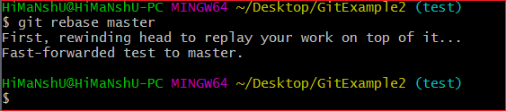

## Git Interactive Rebase

Git facilitates with Interactive Rebase; it is a potent tool that allows various operations like **edit, rewrite, reorder,** and more on existing commits. Interactive Rebase can only be operated on the currently checked out branch. Therefore, set your local HEAD branch at the sidebar.

Git interactive rebase can be invoked with rebase command, just type **-i** along with rebase command. Here '**i**' stands for interactive. Syntax of this command is given below:

**Syntax:**

1. $ git rebase -i

It will list all the available interactive options.

**Output:**

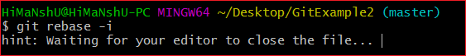

After the given output, it will open an editor with available options. Consider the below output:

**Output:**

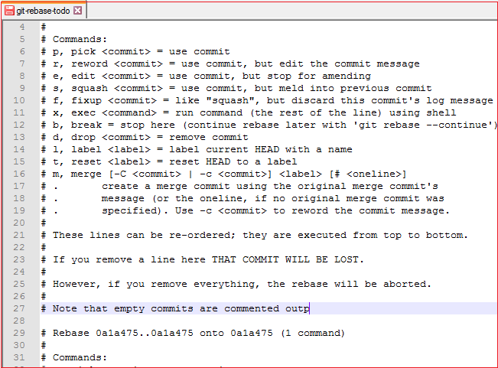

When we perform the git interactive rebase command, it will open your default text editor with the above output.

The options it contains are listed below:

* Pick
* Reword
* Edit
* Squash
* Fixup
* Exec
* Break
* Drop
* Label
* Reset
* Merge

The above options perform their specific tasks with git-rebase. Let's understand each of these options in brief.

**Pick (-p):**

Pick stands here that the commit is included. Order of the commits depends upon the order of the pick commands during rebase. If you do not want to add a commit, you have to delete the entire line.

**Reword (-r):**

The reword is quite similar to pick command. The reword option paused the rebase process and provides a chance to alter the commit message. It does not affect any changes made by the commit.

**Edit (-e):**

The edit option allows for amending the commit. The amending means, commits can be added or changed entirely. We can also make additional commits before rebase continue command. It allows us to split a large commit into the smaller commit; moreover, we can remove erroneous changes made in a commit.

**Squash (-s):**

The squash option allows you to combine two or more commits into a single commit. It also allows us to write a new commit message for describing the changes.

**Fixup (-f):**

It is quite similar to the squash command. It discarded the message of the commit to be merged. The older commit message is used to describe both changes.

**Exec (-x):**

The exec option allows you to run arbitrary shell commands against a commit.

**Break (-b):**

The break option stops the rebasing at just position. It will continue rebasing later with '**git rebase --continue**' command.

**Drop (-d):**

The drop option is used to remove the commit.

**Label (-l):**

The label option is used to mark the current head position with a name.

**Reset (-t):**

The reset option is used to reset head to a label.

## GitMerge vs. Rebase

It is a most common puzzling question for the git user's that when to use merge command and when to use rebase. Both commands are similar, and both are used to merge the commits made by the different branches of a repository.

Rebasing is not recommended in a shared branch because the rebasing process will create inconsistent repositories. For individuals, rebasing can be more useful than merging. If you want to see the complete history, you should use the merge. Merge tracks the entire history of commits, while rebase rewrites a new one.

Git rebase commands said as an alternative of git merge. However, they have some key differences:

|  |  |
| --- | --- |
| **Git Merge** | **Git Rebase** |
| Merging creates a final commit at merging. | Git rebase does not create any commit at rebasing. |
| It merges all commits as a single commit. | It creates a linear track of commits. |
| It creates a graphical history that might be a bit complex to understand. | It creates a linear history that can be easily understood. |
| It is safe to merge two branches. | Git "rebase" deals with the severe operation. |
| Merging can be performed on both public and private branches. | It is the wrong choice to use rebasing on public branches. |
| Merging integrates the content of the feature branch with the master branch. So, the master branch is changed, and feature branch history remains consistence. | Rebasing of the master branch may affect the feature branch. |
| Merging preserves history. | Rebasing rewrites history. |
| Git merge presents all conflicts at once. | Git rebase presents conflicts one by one. |